

**is**

**Connecting Local People**

|  |
| --- |
| **With Your Town’s Local Businesses!** |

[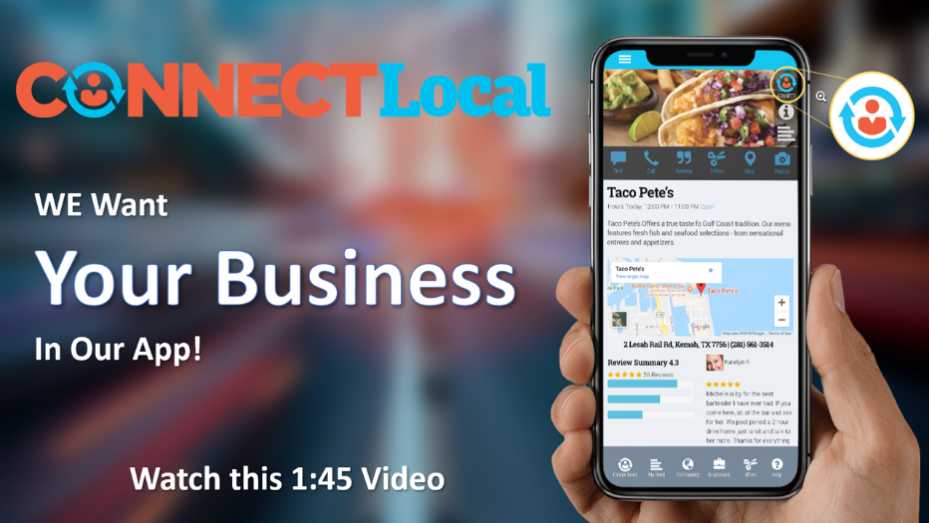](https://www.localproject.net/self-signup/)

**Step 1 – Create Your Free Account**

Watch Video

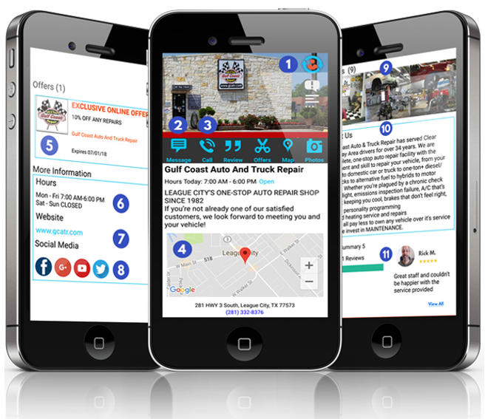

* **Businesss Profile Tells Your Story**
* **Promote 2 Special Offers**
* **No Redemption or Transaction Fees**
* **Dashboard to Change Content & Offers In Real-Time**

**Shop Local – Support Local Business**

**FREE**

**Bronze Listing**

**Good**

**Includes:**

Basic Profile with Address, Hours, Map & Directions

Promotion of 2 Special Offers in Local Marketplace

**Step 2 - Upgrade to Get the Power of Mobile Messaging!**

|  |  |  |
| --- | --- | --- |
| **1**  **Inbound SMS Texts**  On Your Existing Landline  or Provided Dedicated Text Line  Telephone  Manage from your PC or your Cellphone without revealing your personal cell number | **2**  **Customer Service Texts**  Send Customer Service Texts from your PC, laptop or tablet.  Chat   * Announce Service Truck Arrivals * Notify Ready for Pickup * Appt & Service Reminders * Emergency Alerts | **3**  **Customer Engagement**  Get Everything You Need to Send  Mobile Alerts News & Offers  Computer  **Mobile Engage with Your Customers!**  Grow Sales by 10%+ Year to Year Mobile Connected Customers purchase 7X more than Social Media |

**2 Easy Upgrade Steps – Activate Your Messaging & Choose Your Plan**

1

2

|  |  |
| --- | --- |
| **Mobile Activation, Support & Training**  **Only $99** | **Assisted Support Includes:**   * SMS Activation of One Landline or Dedicated Number * Professional Setup of Enhanced Business Profile w/images * Marketing Support for VIP List Growth & Special Offers * Live Webinar Training with Your Staff Reviewing Functionality |
| **Gold Membership**  **Just $59/mo - Better**  Select Annual Get 2 Months Free!  **Platinum Membership**  **Just $89/mo – Best** | **Membership Includes**:   * Boosted or Featured CONNECTLocal Placement * Enhanced Business Profile Tells Even More * Landline SMS Texting Via Desktop PC * Customer Service Messaging & Customer Engagement System * FREE In-Network Messages * SMS Messages Gold .02 - SMS Messages Platinum .01 |

**Step 3 - Connect with Existing Customers & Send Your Alerts & Offers**

**Users Connect**

**Customers Buy**

**Businesses Send**

Mobile Alerts are Read 5 Times More Often than Email – Mobile Offers are Redeemed 8 Times More Often than Email

**Signup & Get Your Business Registered TODAY!**

**To Register Your Business**

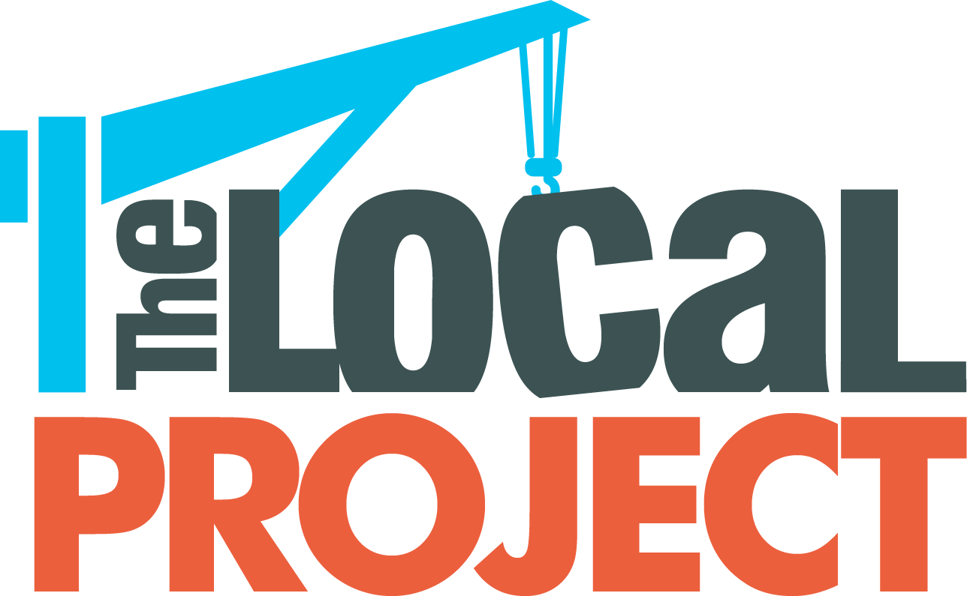



**Call (281) 500-1450**

**Ask for Nancy Shaffner**

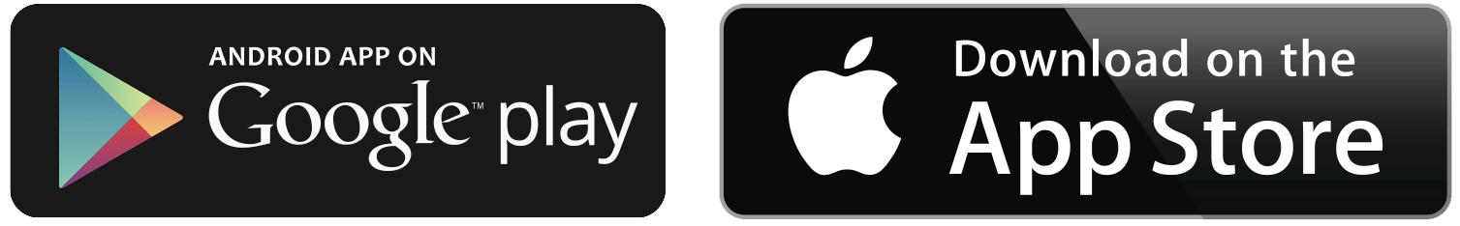

www.localproject.net